Kid’s Cakes 101 - Buttercream  This class is designed to introduce students to the very basics of cake decorating by demonstrating the ease and fun of cake decorating. Students will be able to create their own cake using the skills they'll learn in class. All supplies and tools will be provided. The cake design will change every two months. Cost is $35 per child, ages 7-15.  Halloween Jack o lantern  Sunday, October 13th  3:00pm – 4:30pm  Mommy & Me Cookie Decorating  This class is designed for parents and their littles to learn how to decorate while bonding. Each pair of students will be able to take home six cookies, recipes, and tons of knowledge to create your own stunning cookies for years to come. Cost is $45 per person. Ages 4+. Cost includes one parent and one child.  Sunday, October 20th  4:00pm – 6:00pm  To register for classes, please visit our website at www.westtexascakesupplies.com |  |  | Who We Are  About Us  West Texas Cake Supplies is a home based cake supply shop. Our main focus is providing cake, cookie, cupcakes, and other decorating classes to San Angelo, all while building an inventory of supplies you cannot find in West Texas.  To register for classes, please visit our website at www.westtexascakesupplies.com  Contact Us  Phone: 713-885-7410  Email: info@westtexascakesupplies.com  Web: www.westtexascakesupplies.com  *by appointment only.  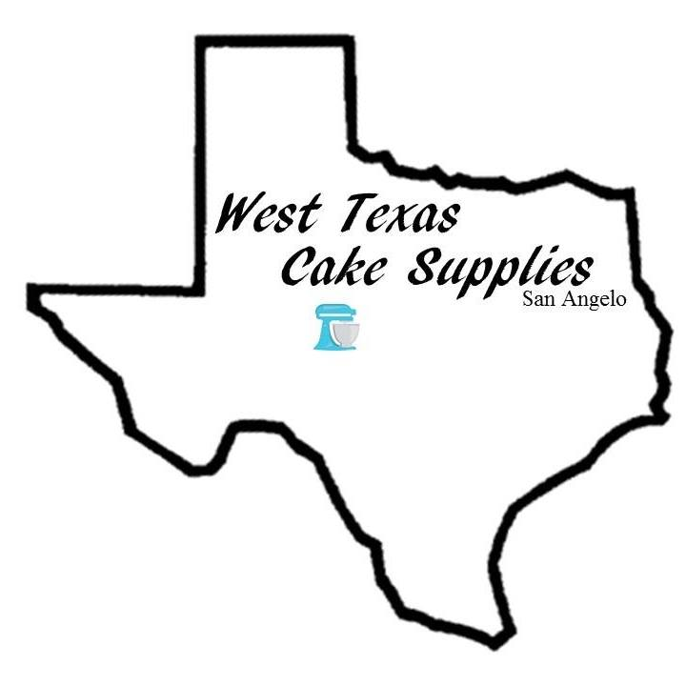 West Texas Cake Supplies 2223 Wilson St. San Angelo, TX 76901 |  |  | West Texas Cake Supplies Current Class Schedule  713-885-7410  2223 Wilson St.  San Angelo, TX 76901

Cakes 101 – Beginner Cake Decorating  In this three hour class, we will review how to bake a cake and buttercream, ice a cake, border a cake, write on a cake, review different types of icing tips, as well as, decorate your very own cake! All supplies will be provided, as well as an 8" round, double layer cake for you to take home. Cost is $50 per person. Ages 12+  Saturday, September 14th  12:00pm – 3:00pm  -----  Saturday, October 5th  9:00am – 12:00pm  Cakes 201 – Buttercream Flowers  It is highly recommended to attend a Cakes 101 class before attending this class. In this TWO PART class, we will be learning how to create several different flowers using buttercream in class one, and in class two, we will learn and decorate a basket weave cake using the flowers you made in class one. All supplies and tools are included. $50 per person. Ages 12+  Saturday, September 21st & 28th  12:00pm – 1:30pm  -----  Saturdays, November 9th & 16th  10:00am – 11:30am  To register for classes, please visit our website at www.westtexascakesupplies.com |  |  | Football Cookies for Beginners  This class is designed for beginner decorators. Each student will be able to take home six cookies, recipes, and tons of knowledge to create your own stunning cookies for years to come. Cost is $45 per person. Ages 12+  Thursday, September 19th  6:00pm – 8:00pm  Halloween Cookie Bouquet  This class is designed for beginner decorators. Each student will be able to take home six cookies, recipes, and tons of knowledge to create your own stunning cookie bouquets for years to come. Cost is $50 per person. Ages 12+  Saturday, October 19th  9:00am – 12:00pm  Halloween Cupcakes & Pops  This class is designed to learn several skill sets; cupcake decorating, cake pops, rice crispy pops, oreo pops, and more. Cost is $65 per person. Ages 12+  Saturday, October 26th  9:00am – 12:00pm  To register for classes, please visit our website at www.westtexascakesupplies.com |  |  | Private Classes:  Private classes can be scheduled around your schedule and Emily’s availability. Because we customize the classes, the length of the Private Lessons can vary, but do require a two hour minimum at $20/hour. There may be additional costs, depending on supplies and tools needed for the lesson.  Note:  All costs of classes include all supplies, tools, and ingredients needed for the class.  To register for classes, please visit our website at www.westtexascakesupplies.com

